DATA COLLECTION CARD

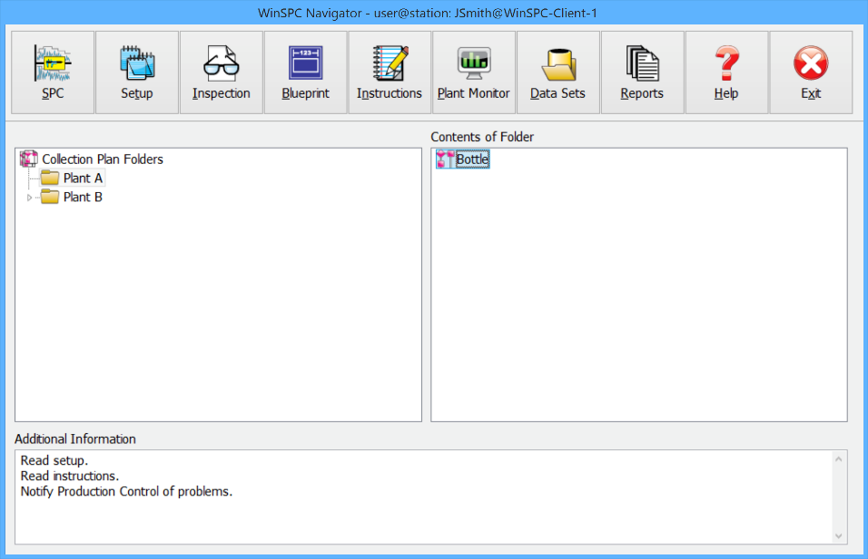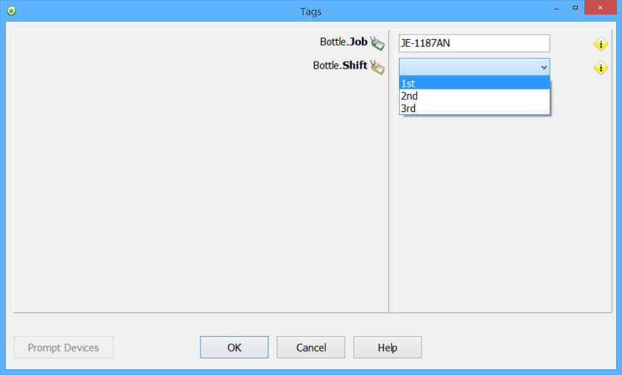

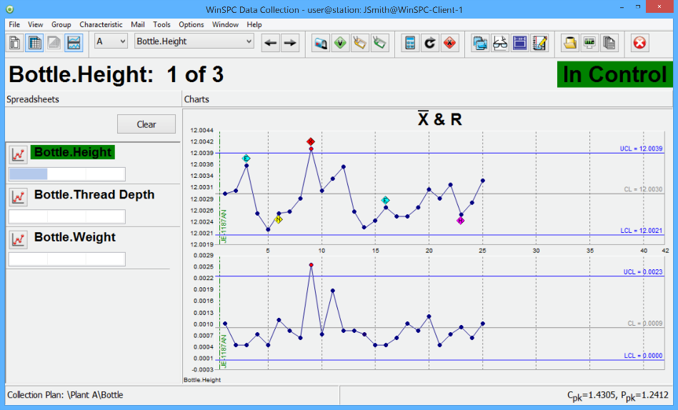

**STEP 3**

Enter or monitor data and respond to alarms

**STEP 2**

Enter, select, or scan tags

**STEP 1**

Double-click a collection plan